KNOWLEDGE & TECHNOLOGY

Bangladesh Army University of Engineering & Technology

**

Department of Computer Science and Engineering

A project report on

**Boral Hall Management System**

A project is submitted in partial fulfillment of the requirements of the degree of Bachelor of Science in Computer Science and Engineering.

Submitted by

Supervised by

Department of Computer Science and Engineering

Bangladesh Army University of Engineering & Technology

June, 2022

KNOWLEDGE & TECHNOLOGY

Bangladesh Army University of Engineering & Technology

Department of Computer Science and Engineering

**

**CERTIFICATE**

This is to certify that the project entitled **“Boral Hall Management System”** by

has been accepted as satisfactory in partial fulfillment of the requirement for the degree of Bachelor of Science in Computer Science and Engineering on June, 2022.

Signature of Supervisor

**………………………………**

(Teacher Name)

(Associate Professor & Head)

Department of Computer Science and Engineering (CSE)

Bangladesh Army University of Engineering & Technology (BAUET)

KNOWLEDGE & TECHNOLOGY

Bangladesh Army University of Engineering & Technology

Department of Computer Science and Engineering

**

**DECLARATION**

We hereby declare that project titled **“Boral Hall Management System”** is a debonair Project. We also ensure that it does not previously submit or published elsewhere for the award of any degree or diploma.

The work has been accepted for the degree of Bachelor of Science in Computer Science and Engineering at Bangladesh Army University of Engineering & Technology (BAUET).

**Author (s)**

**……………………… …………………………… …………………….**

**ACKNOWLEDGMENT**

At first, we would like to pray to Almighty Allah to give us the scope for successful completion of our thesis work.

First and foremost, we would like to thank to our supervisor, **Teacher Name**, Associate Professor and Head, Department of Computer Science and Engineering, Bangladesh Army University of Engineering & Technology, Qadirabad who has been a source of tireless and patient guidance, advisement, and knowledge. This thesis could not be completed without his best directions, advice, and novel ideas.

We are very grateful to our respective teachers of Department of Computer Science and Engineering, Bangladesh Army University of Engineering & Technology, Qadirabad for their valuable suggestions, extending facilitation and inspiration time to time.

We are cordially thankful to laboratory staff of CSE department for their co-operation and amiable behavior.

Finally, we wish to extend our appreciation and thank to our family specially our beloved parents and all our well-wishers for their unconditional love, prayer and support.

**ABSTRACT**

As the name specifies "Smart Hall Management System" is a software developed for managing various activities in the hall. For the past few years the number of educational institutions is increasing rapidly. Thereby the number of halls is also increasing for the accommodation of the students studying in this institution. And hence there is a lot of strain on the person who are running the hall and software's are not usually used in this context. This particular project deals with the problems on managing a hall and avoids the problems which occur when carried manually. We proposed an organizing digital system for Boral Hall Management. A secured digital student record can only be accessed and managed by authorized personnel. This ensures that a student's privacy is protected because not just anybody can see their academic record. More importantly, it prevents improper editing, theft or destruction of a student's academic record. Identification of the drawbacks of the existing system leads to the designing of computerized system that will be compatible to the existing system with the system which is more users friendly and more GUI oriented. We can improve the efficiency of the system, thus overcome the drawbacks of the existing system.

|  |  |  |
| --- | --- | --- |
| **List of Contents** | | |
| **Chapter** | **Title** | **Page No.** |
|  | Certificate | i |
|  | Declaration | ii |
|  | Acknowledgment | iii |
|  | Abstract | iv |
|  | List of contents | v |
|  | List of figures | vii |
|  | List of tables | viii |
|  | Abbreviations | ix |
|  |  |  |
| **1** | **INTRODUCTION** | **1-5** |
|  | 1.1 Introduction | 1 |
|  | 1.2 Background of Project | 2 |
|  | 1.3 Project Aims and Objectives | 2 |
|  | 1.4 Operational Environment | 3 |
|  | 1.5 Motivation | 4 |
|  | 1.6 Conclusion | 5 |
|  |  |  |
| **2** | **SYSTEM ANALYSIS** | **6-10** |
|  | 2.1 Introduction | 6 |
|  | 2.2 Software Requirement Specification | 7 |
|  | 2.3 Existing VS Proposed | 7 |
|  | 2.4 Software Tools Used | 8 |
|  | 2.5 Target Customer | 9 |
|  | 2.6 Market Analysis | 9 |
|  | 2.7 Conclusion | 10 |
|  |  |  |
| **3** | **SYSTEM DESIGN** | **11-17** |
|  | 3.1 Introduction | 11 |
|  | 3.2 Table Design | 14 |
|  | 3.3 USE Case Diagram | 15 |
|  | 3.4 ER Diagram | 16 |
|  | 3.5 Data Flow Diagram | 17 |
|  | 3.6 Conclusion | 18 |
|  |  |  |
| **4** | **SYSTEM IMPLEMENTAION** | **19-28** |
|  | 4.1 Introduction | 19 |
|  | 4.2 Module Description | 20 |
|  | 4.3 Screen Shots  4.4 Conclusion | 22  28 |
| **5** | **SYSTEM TESTING AND INTEGRATION** | **29-37** |
|  | 5.1 Introduction | 29 |
|  | 5.2 Features to be Tested/ Not to be Tested | 30 |
|  | 5.3 Testing Schedule | 32 |
|  | 5.4 Test Cases | 33 |
|  | 5.5 Unit Testing | 35 |
|  | 5.6 Integration Testing | 36 |
|  | 5.7 Conclusion | 37 |
|  |  |  |
| **6** | **SYSTEM ISSUES** | **38-40** |
|  | 6.1 Introduction | 38 |
|  | 6.2 Risk Analysis | 38 |
|  | 6.3 Cost Analysis | 39 |
|  | 6.4 Conclusion | 40 |
|  |  |  |
| **7** | **MAINTENANCE** | **41-44** |
|  | 7.1 Introduction | 41 |
|  | 7.2 Runtime Maintenance | 42 |
|  | 7.3 System Security | 42 |
|  | 7.4 Conclusion | 44 |
|  |  |  |
| **8** | **CONCLUSION & FUTURE SCOPE** | **45** |
|  |  |  |
|  | **REFERENCES** | **46-47** |
|  |  |  |

|  |  |  |
| --- | --- | --- |
|  | **List of Figures** |  |
| **Figure No.** | **Title** | **Page No.** |
| 3.1 | Smart Hall Management System Proposed Model | 12 |
| 3.2 | Smart Hall Management System Gantt Chart | 13 |
| 3.3 | Table View of Smart Hall Management System | 14 |
| 3.4 | Overall Use-Case Smart Hall Management System | 15 |
| 3.5 | E-R Diagram Smart Hall Management System | 16 |
| 3.6 | Level 0 Smart Hall Management System DFD | 17 |
| 3.7 | Level 1 Smart Hall Management System DFD | 17 |
| 3.8 | Level 2 Smart Hall Management System DFD | 17 |
| 4.1 | Home Page | 22 |
| 4.2 | Student Allotment | 22 |
| 4.3 | Meal Chart | 23 |
| 4.4 | Hall Dues | 23 |
| 4.5 | Hall House Tutor | 24 |
| 4.6 | Complaints From | 24 |
| 4.7 | Student FAQ | 25 |
| 4.8 | View Complaints | 25 |
| 4.9 | View Feedback | 26 |
| 4.10 | Add New Student | 26 |
| 4.11 | Update House Tutor | 27 |
| 4.12 | Hall Provost | 27 |
|  |  |  |

|  |  |  |
| --- | --- | --- |
|  | **List of Tables** |  |
| **Table No.** | **Title** | **Page No.** |
| 5.1 | List of features that will be tested and not tested | 31 |
| 5.2 | Login test case | 33 |
| 5.3 | Member module test cases | 34 |
| 5.4 | Product module test case | 35 |

|  |  |
| --- | --- |
| **Abbreviation** | |
| WAMP | Window, Apache, MySQL, PHP |
| PHP | Hypertext Preprocessor |
| SQL | Structured Query Language |
| CD | Compact Disk |
| RAM | Random Access Memory |
| CSS | Cascading Style Sheet |
| HTML | Hyper Text Markup Language |
| GUI | Graphical User Interface |
| BR | Business Rule |
| IE | Internet Explorer |
| UML | Unified Modeling Language |

**Chapter 1**

**INTRODUCTION**

* 1. **Introduction**

This system is designed in favor of the hall management which helps them to save the records of the students about their rooms and other things. It helps them from the manual work from which it is very difficult to find the record of the students and the mess bills of the students, and the information of about those ones who had left the hall Al the halls at present are managed manually by the hall office.

The Registration form verification to the different data processing is done manually. Thus there are a lot of repetitions which can be easily avoided. And hence there is a lot of strain on the person who are running the hall and software's are not usually used in this context. [1] This particular project deals with the problems on managing a hall and avoids the problems which occur when carried manually Identification of the drawbacks of the existing system leads to the designing of computerized system that will be compatible to the existing system with the system which is more user friendly.

We can improve the efficiency of the system, thus overcome the drawbacks of the existing system. We design this system of the hostel management especially for the college hostel, through this they cannot require so efficient person to handle and calculate the things. This system automatically calculates all the bills and issued the notifications for those students who are against some rules. [7]

This is a six storeyed hall for the accommodation of male students of BAUET. The hall is given its name according to the prominent river ‘Boral’ of Natore. Number of seat capacity is 466. The hall provides various facilities for the comfort and pleasure of the students, such as modern building and room with tiles, steel cot etc. But hall services will better when student get a digital management system. That creates a connection between hall staff and student.

* 1. **Background of Project**

This software product the hall management to improve their services for all the students of the hall. This also reduce the manual work of the persons in admin penal and the bundle of registers that were search when to find the information of a previous student, because through this system you can store the data of those students who had left the hall. [3] Through this you can check the personal profile of all the current students within few minutes the database of the system will help you to check a particular one. The system will help you to check the mess bills of every student and the student's hall dues. The students of the hall will be recognized from the ID number allocated at the room rental time. In the last this system will improve the management work in the hall.

* To provide a quick response with very accurate information as and when required
* To make the present manual system more interactive, speedy and user friendly
* To avail any information, whatever and whenever needed
* Reduce the cost of maintenance
  1. **Project Aims and Objectives**

This system is designed in the favor of the Hall Management, which helps them to save the records of the students about their rooms and other things. It helps them from the manual work from which it is very difficult to find the record of the students and the mess bills of the students, and the information about those students who left the hall some years before. It also helps them to retrieve the staff details. This system also carries out the automatic allotment or evacuation of rooms for the students and also, automatically calculates all the bills and issues the notifications for those students who are against some rules. [4] Thus, in order to ease the process, we need to develop software which can handle all the aforementioned problems. To replace the existing system which is much more time consuming, we are developing a software which is user-friendly and its functionality is very good compared to the existing one.

* This software makes the user to store the details of the student in a data base and it is easy to retrieve the data whenever necessary.
* We can say that this product has the highest priority because it is going to be a good product according to us.
* User should log in this software to use it. It can be used only by one person called the Manager to enter the student/staff records etc.
* Its validation is done standard as it looks very impassive system product.
  1. **Operational Environment**

The operational environment is the environment in which systems are deployed. In another word, these are the hardware and software that will be used to develop the whole project. Here is the description of the environment that which the software was developed

* Hardware specification
* Removal disk.
* Processor –Intel Core i5.
* Printer –for printing document
* Hard disk-For storage of data
* Software specification
  + Language: PHP5, CSS, HTML, JavaScript.
  + Operating System: Windows 8
  + Data storage: MySQL
  + Browser: Any latest browsers, i.e., Chrome, Firefox, Opera, IE.
  1. **Motivation**

Students are one of the most important assets to any university. They are the people who represent the university in the real world. Firstly, to book a room at hostel we need to come early in the morning to hostel for the better selection of rooms. And then when the process starts each floor is allocated to a minimum of 2-3 hall officials and then these people will be giving a token number to each student and it takes a minimum of 2-3 hours to complete this process for all the students. And a day is allocated to first year and the next to their seniors out of whole this process takes minimum 4 to 5 days. And after completion of giving tokens to all the students each student is called according to their token number and then each floor in-charge will check each student payment proof and then by referring to the advanced booking list he/she will be allocated with the room and again if her payment proofs should be considered or not like management do not consider the payments which are paid using local banks if anyone has paid their amount using those banks again their raises an issue and then due to this the other student candidates must wait until the completion.

But using this project many numbers of students can complete their procedure simultaneously which is easy both for the management as well as the student. And for a non hosteller to stay at hall that student first need to get a letter signed from parents and then submit that to transport department and this letter should again be forwarded to the higher officials of halls and they might not be present all the day at their cabins so this takes a minimum of 2-3 days. The proposed system has superior efficiency, and it surmounts the shortcomings of existing technique of hotel management system. Also, it has few advantages while the system is generating such as providing high security, avoiding data redundancy, data consistency, easy handling, stored record, data updating, less laborious work and less human error.

* 1. **Conclusion**

The main advantage of the new system over the traditional system is the empowerment of its users to accomplish its tasks. The system proves to be advantageous for the alumni. Each student is likely to have a unique life experience and the system provide an ideal place for them to share their complaints and personal feedbacks.

**Chapter 2**

**SYSTEM ANALYSIS**

**2.1 Introduction**

Systems analysis is a problem-solving technique that decomposes a system into its component pieces for the purpose of studying how well those component parts work and interact to accomplish their purpose. According to the Merriam-Webster dictionary, systems analysis is the process of studying a procedure or business in order to identify its goals and purposes and create systems and procedures that will achieve them in an efficient way. [4] Analysis and synthesis, as scientific methods, always go hand in hand; they complement one another. Every synthesis is built upon the results of a preceding analysis, and every analysis requires a subsequent synthesis to verify and correct its results.

One of the most important objectives of the establishment of the administration is to link the bridges of practical life with the academy and to support continuous communication between the hall and its students, benefiting the university and its students, as well as conducting research studies on academic developments in order to meet the requirements of the personal space. [6]

This field is closely related to requirements analysis or operations research. It is also an explicit formal inquiry carried out to help someone (referred to as the decision-maker) identify a better course of action and make a better decision than she might otherwise have made

**2.2 Software Requirement Specification**

The software requirements are a description of the features and functionalities of the target system. Requirements convey the expectations of users from the software product. The requirements can be obvious or hidden, known or unknown, expected or unexpected from the client’s point of view. Requirement analysis helps to study the nature of the present situation and it gives a clear picture of the existing process and the weaknesses associated with the current practices. [12] Requirement gathering was performed in two areas; interviews and studying documentation. The main aim of the Smart Hall Management System is to provide a good and strong bridge for the students, teachers, and the hall staff.

This system will be applied to computers and mobile devices which support web browsers. It will work in every dimension of the world and for those students who want to graduate from BAUET. It will enable the new students to be registered, update their profiles, communicate with the other student through messages, retrieve information, and follow up on the university’s missions. [9] For the university it enables communication with their students, announcing the university mission, searching for students, identifying the status of each student, and also delivering discussion forums which participate the student.

The student is also able to feedback on their suggestion about the forum. While designing the website there are some constraints in mind such as the website should be able to run on both mobile and desktop devices and the server-side work or the backend should be designed with such thing in mind that it should be able to respond very fast otherwise the user experience will not be great. [6]

**2.3 Existing VS Proposed**

* The current hall management system involves hand-written records that are stored into various registers.
* This requires a lot of time as well as manpower.
* Each department has its own register and the student and staff registers are maintained on a daily basis.
* It is very difficult to maintain or update all the records and retrieving a certain data from such a number of registers is almost impossible.
* Also, the loss or damage of any of the registers leads to the damage of hundreds of records at a time.

**2.4 Software Tools Used**

This is a web-based project which requires some server-side applications and IDE and much more. The software required for this project but is not limited to be:

1. VS code: Visual Studio Code is a code editor redefined and optimized for building and debugging modern web and cloud applications.
2. Komodo IDE: Komodo Edit is a free and open-source text editor for dynamic programming languages.
3. MySQL: MySQL is an open-source relational database management system. Its name is a combination of “My”, the name of co-founders Michael Wideness’s daughter, and "SQL", the abbreviation for Structured Query Language.
4. GIMP: GIMP is a free and open-source raster graphics editor used for image manipulation and image editing, free-form drawing, transcending between different image file formats, and more specialized tasks.
5. FileZilla: FileZilla is a free and open-source, cross-platform FTP application, consisting of FileZilla Client and FileZilla Server.
6. Notepad++: Notepad++ is a text and source code editor for use with Microsoft Windows. It supports tabbed editing, which allows working with multiple open files in a single window.
7. Chrome: Google Chrome is a cross-platform web browser developed by Google. It was first released in 2008 for Microsoft Windows, built with free software components from Apple Web Kit and Mozilla Firefox.
8. IE: Internet Explorer is a graphical web browser developed by Microsoft, included in the Microsoft Windows line of operating systems.

**2.5 Target Customer**

A target customer is an individual that's most likely to buy your product. And it's a subset of the broader target market. Here when we talk about the target customer of Hall management there are basically 4 types of customers that are available:

* Students
* Hall Staff
* Teachers
* Hall Provost

So our project is much helpful in these contexts. This project is developed based on problems faced by the hostel management and avoids many problems which are caused by man work which causes problems like incorrect data entry and several other problems. [7] By identifying these drawbacks caused by current technique which interrelated for developing an automated and digitalized system known to be the hostel management system which gives much more comfortable and compatible with the existing system and this is the system which is more users friendly.

**2.6 Market Analysis**

A rise in the number of hall management system and an increase in demand for an efficient hall network program is anticipated to drive the hall management software market during the forecast period. The availability of solutions at affordable prices from market players is likely to further fuel the market in the coming years. Colleges and institutions are focusing on building an efficient hall network program to attract better future candidates. Some of the major college hall management system is Columbia University, Boston University Alumni Council, Harvard University, Dartmouth University, and Stanford University. However, the availability of open-source hall management software is expected to hinder the market during the forecast period. A major trend observed in the market is the integration of hall management software with CRM solutions. This integration helps an institute to get a 360-degree view of student interactions. [8]

**2.7 Conclusion**

A hall management portal allows a student to register with hostel and book a room and for staying at hostel for a period of time and for any new announcements regarding events or any other important things can be known to students through this portal. Student can provide feedback through online using this portal. Numerous numbers of institutions, Industries and firms, hall, paying guest rooms etc. will accept such type of applications and it seems to be more reliable, effective, time saving and less economic.

**Chapter 3**

**SYSTEM DESIGN**

**3.1 Introduction**

Findings of the requirement analysis phase were taken into consideration when designing the system. A good design leads to a successful implementation. This chapter describes the desired features and the operations of the system in detail, using screen layouts, process diagrams, and database diagrams. While the software is being conceptualized, a plan is chalked out to find the best possible design for implementing the intended solution. [6] Out of the following alternative solutions, developing a web-based application was selected as the best possible solution to implement the system.

Solution 1: Develop a web-based application

After the design stage, the system could be implemented as a web solution using reusable codes and components. This way the system would have the features and attributes the association needed. Reusing existing components will speed up the work and enhance the quality of the system. The web solution will allow the office bearers to use the system from anywhere and it will be accessible for the members as well. Furthermore, this approach enables customization in future releases. [5]

Solution 2: Develop a standalone application

Currently, the association is managing the data manually. A standalone system could be implemented for the office bearers of the association. The main issues that can occur are the members will not have any interaction with the system so self-registration, communication, and even registration will not be possible. The office bearers will have to visit association premises to use the system. This approach was rejected as the information needed to be accessible from multiple computers.

**Smart Hall Management System Proposed Model:**

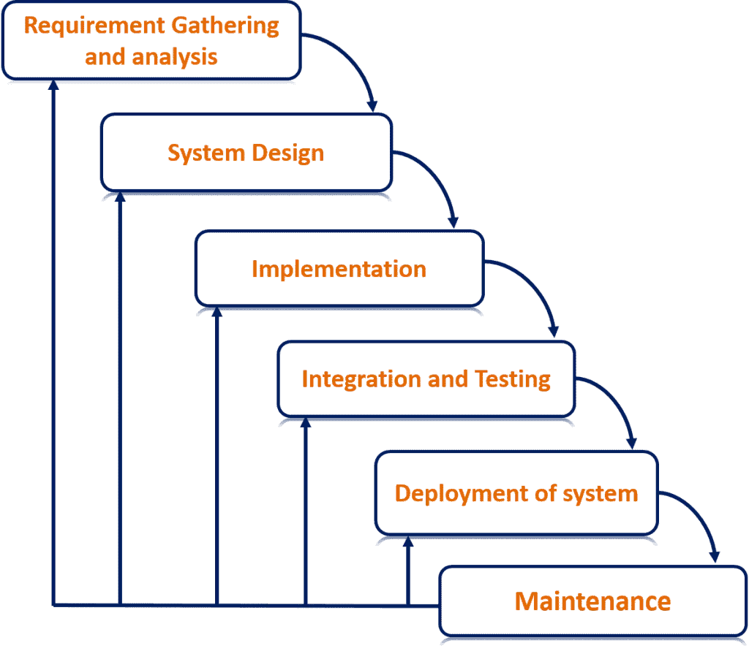

Fig 3.1: Smart Hall Management System Proposed Model

Here we choose waterfall model for our project development. The waterfall model is a breakdown of project activities into linear sequential phases, where each phase depends on the deliverables of the previous one and corresponds to a specialization of tasks. The approach is typical for certain areas of engineering design.

**Smart Hall Management System Gantt Chart:**

|  |  |  |  |  |  |  |  |  |  |  |  |  |
| --- | --- | --- | --- | --- | --- | --- | --- | --- | --- | --- | --- | --- |
| Task | Jul | Aug | Sep | Oct | Nov | Dec | Jan | Feb | Mar | Apr | May | Jun |
| **Task 1**  Requirement Gathering and Analysis |  |  |  |  |  |  |  |  |  |  |  |  |
| **Task 2**  System Design |
| **Task 3**  Implementation |
| **Task 4**  Integration and Testing |
| **Task 5**  Deployment and Maintenance |

Fig 3.2: Smart Hall Management System Gantt Chart

A software development life cycle (SDLC) model is a conceptual framework describing all activities in a software development project from planning to maintenance. This process is associated with several models, each including a variety of tasks and activities. Software Development Life Cycle (SDLC) is a process used by the software industry to design, develop and test high quality software’s. The SDLC aims to produce high-quality software that meets or exceeds customer expectations, reaches completion within times and cost estimates.

**3.2 Smart Hall Management System Table Design**

Fig 3.3: Table View of Smart Hall Management System

**3.3 Smart Hall Management System Overall USE-Case Diagram**

Fig 3.4: Overall Use-Case Diagram of Smart Hall Management System

**3.4 Smart Hall Management System E-R Diagram**

Fig 3.5: E-R Diagram of Smart Hall Management System

**3.5 Smart Hall Management System Data Flow Diagram**

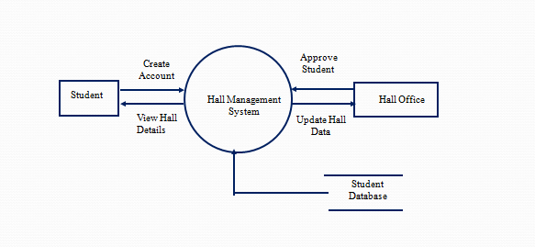

Fig 3.6: Level 0 Smart Hall Management System Data Flow Diagram

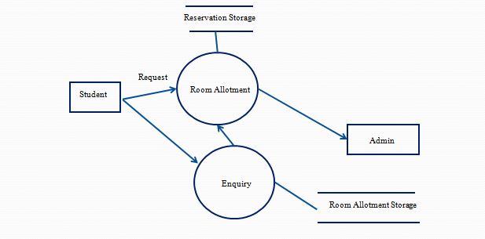

Fig 3.7: Level 1 Smart Hall Management System Data Flow Diagram

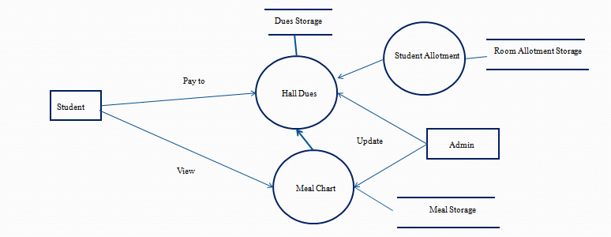

Fig 3.8: Level 2 Smart Hall Management System Data Flow Diagram

**3.6 Conclusion**

We expect after the adoption of the project and its application to the university in the student's department and it is expected that the level of the university will rise for the rest of the universities thanks to this project, which will show the actual output of students at the university.

**Chapter 4**

**SYSTEM IMPLEMENTATION**

**4.1 Introduction**

Implementation converts the concept presented in the design into an outcome. The latest available technologies had been used to implement the system. This chapter presents the implementation environment, implementation approach, and coding details implementation is the process that actually yields the lowest-level system elements in the system hierarchy (system breakdown structure). System elements are made, bought, or reused. [11] Production involves the hardware fabrication processes of forming, removing, joining, and finishing, the software realization processes of coding and testing, or the operational procedures development processes for operators' roles. [10] If implementation involves a production process, a manufacturing system that uses the established technical and management processes may be required.

A suitable environment has to be established to ensure that the implementation process runs smoothly. Hardware was used to implement the system efficiently and to get the best performance of the software. When choosing software compatibility, features were considered and more attention was given to choosing free and open-source software. [4] [5]

Following languages and technologies had been used for system development

* PHP
* HTML
* CSS
* JavaScript
* jQuery

Following software and development tools had been used with the above languages and technologies.

* Windows 10 Pro operating system
* XAMPP version 5.6.31 including Apache server 2.4.26
* PHP 5.6.31
* Php MyAdmin 4.7.0
* NetBeans IDE 8.2
* Adobe Photoshop CS6
* VS Code
* Notepad++

The System was implemented in a computer having the following hardware configurations.

* Intel® Core TM i5 Duo CPU 1.60 GHz
* 4 GB RAM
* 1 TB Hard disk

**4.2 Module Description**

A module is a collection of source files and builds settings that allow you to divide your project into discrete units of functionality. Your project can have one or many modules, and one module may use another module as a dependency. You can independently build, test, and debug each module. [6]

Additional modules are often useful when creating code libraries within your own project or when you want to create different sets of code and resources for different device types, such as phones and wearable’s, but keep all the files scoped within the same project and share some code.

Here while building Smart Hall Management System, we used many modules as there is much use of the system, and using modules, we can divide the different functions into different modules which will help to run, debug or maintain the code much better.

Here are some list examples of modules that are used in Smart Hall Management System:

1. Create an account: This module helps to create a new account

2. Update Account: This module helps to update an existing account

3. Portfolio Generator: This module helps to generate a Personal portfolio

4. Give Complaints: This module helps student give the complains

5. View Meal Chart: This module helps members view the meal chart

6. View Hall Dues: This module helps student view hall dues

7. View House Tutors: This module helps student members to view house tutor

8. View Allotment: This module helps student members to view the allotment

REUSED MODULES

Folio Gallery

It is a photo gallery implemented using the technologies PHP, AJAX, and jQuery. It is a simple and lightweight gallery that does not require a database to run. It has features such as displaying multiple albums and/or a full gallery on one-page, automatic thumbnail creation, enabling captions for thumbnails, etc. [6] [10]

jQuery Date Picker

It is a highly customizable plugin for bootstrap that supports multiple languages. [11]

Fusion Charts

It is a JavaScript charting solution for web and mobile. It supports basic charts such as line, column, pie, etc., and most complex ones such as waterfall, Gantt, candlestick, zoom line, etc. [12]

Data Tables

Data Tables is a free and open-source plug-in for the jQuery JavaScript library. It is a highly flexible tool and adds advanced interaction controls to any HTML table. It supports Pagination, instant search, and multi-column ordering. [13]

**4.3 Screen Shots**

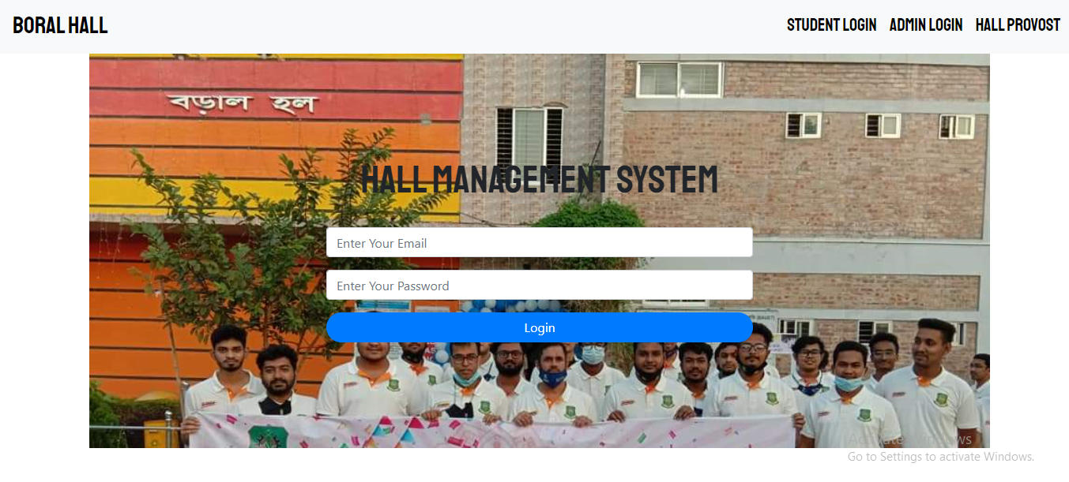

Fig 4.1: Home Page

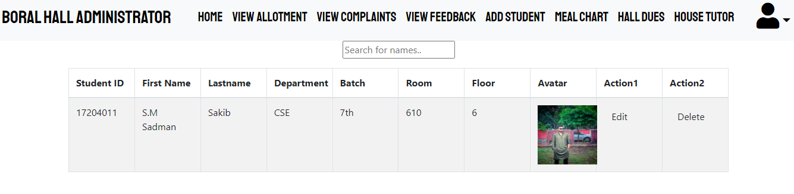

Fig 4.2: Student Allotments

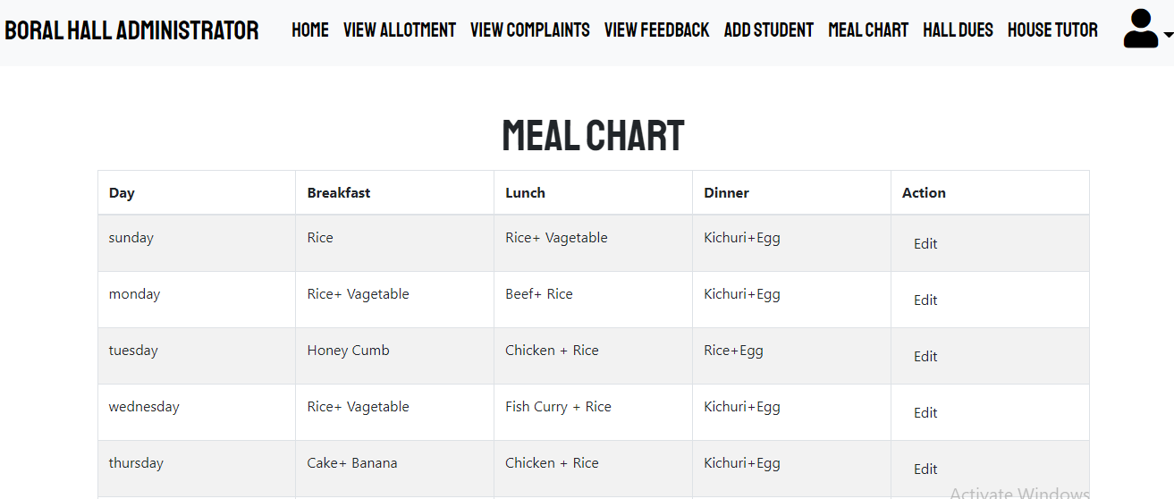

Fig 4.3: Meal Chart

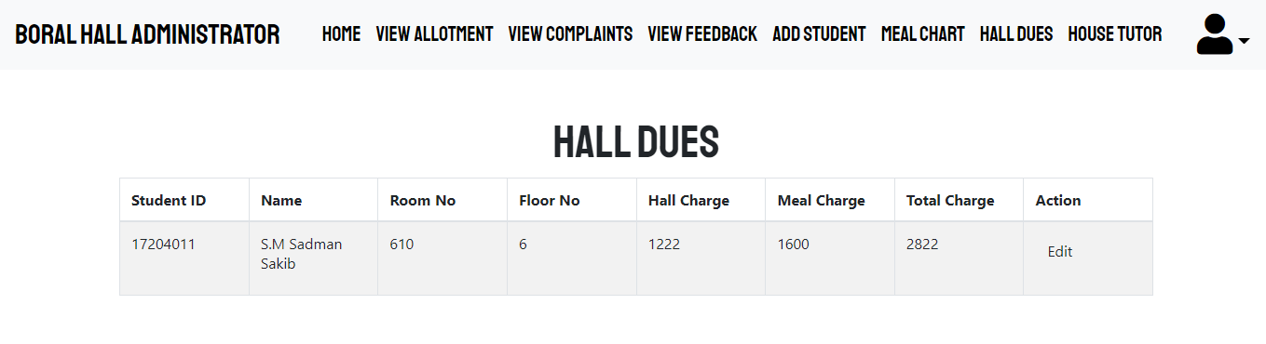

Fig 4.4: Hall Dues

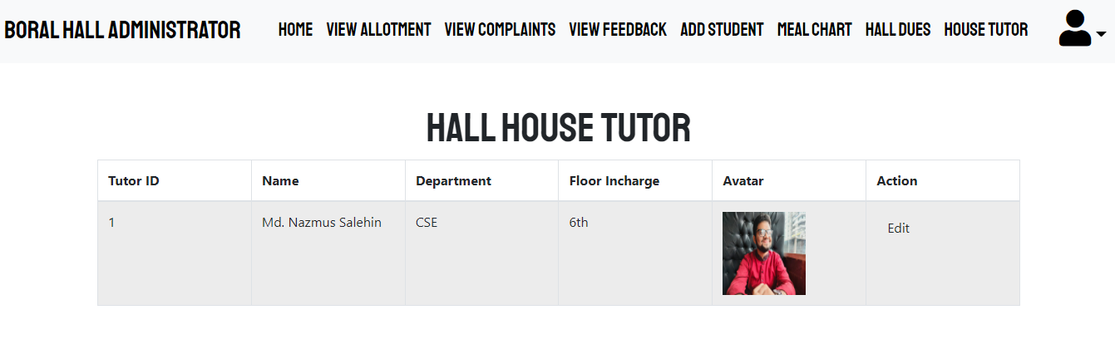

Fig 4.5: Hall House Tutor

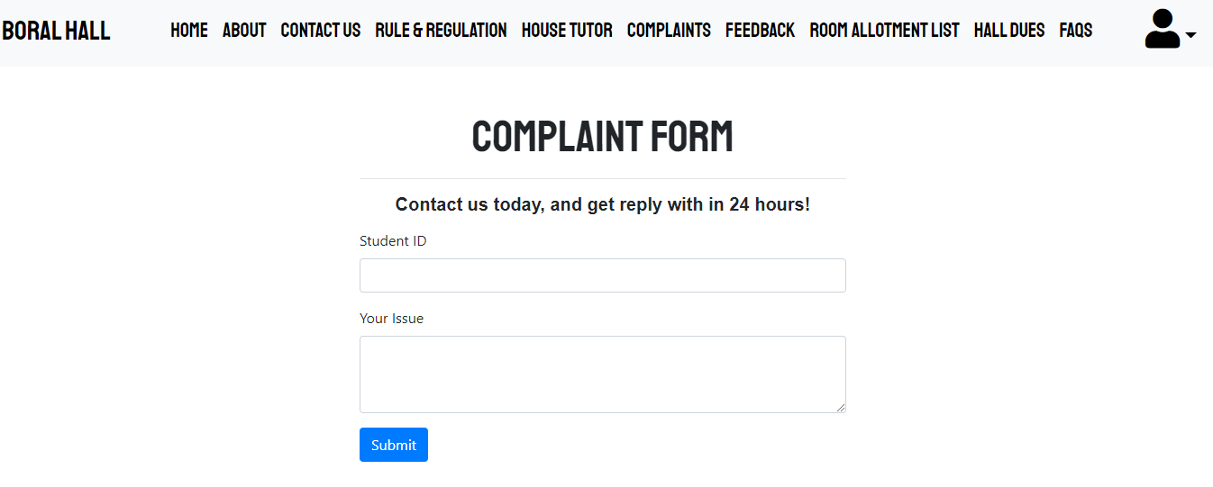

Fig 4.6: Complaints From

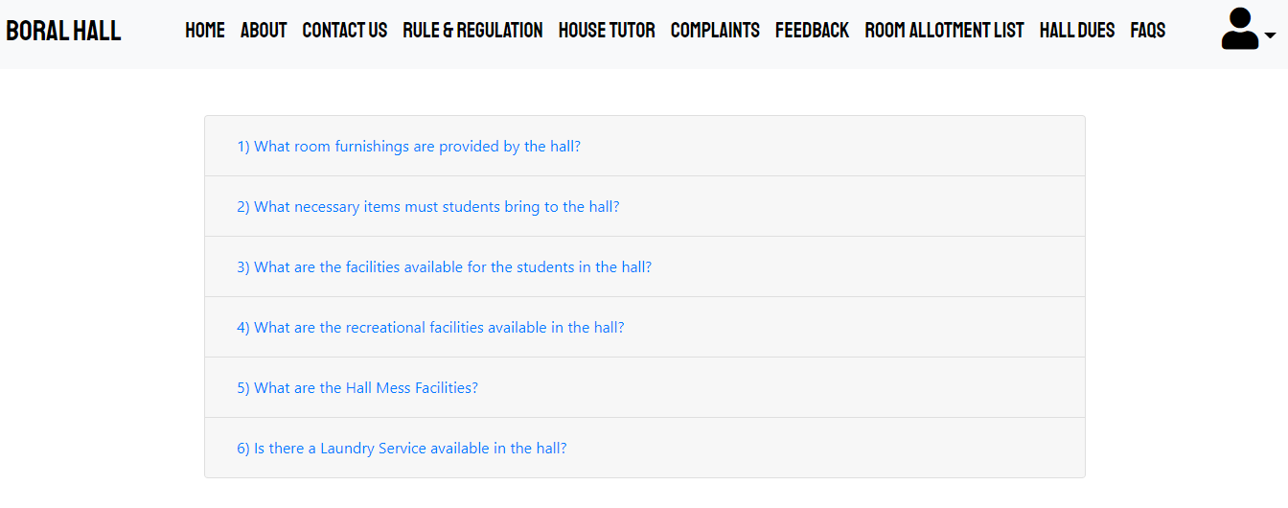

Fig 4.7: Student FAQ

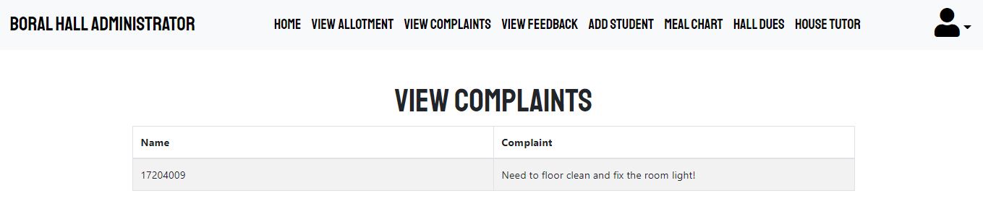

Fig 4.8: View Complaints

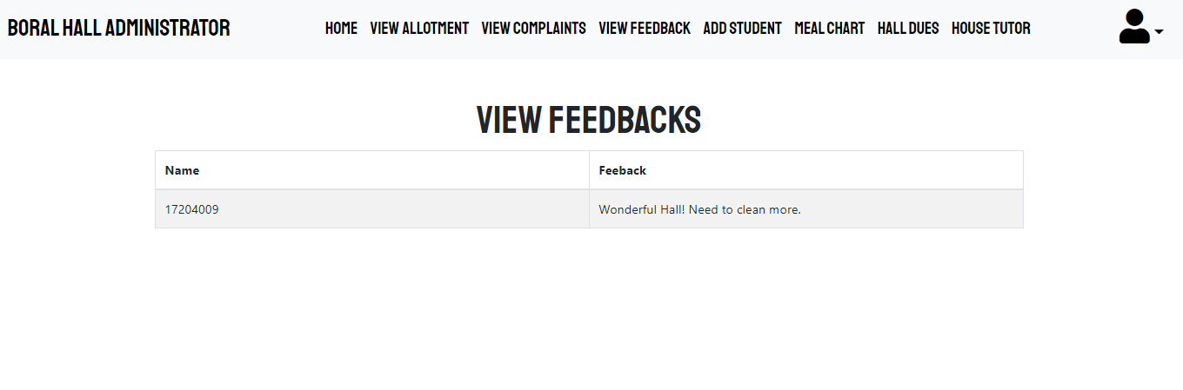

Fig 4.9: View Feedbacks

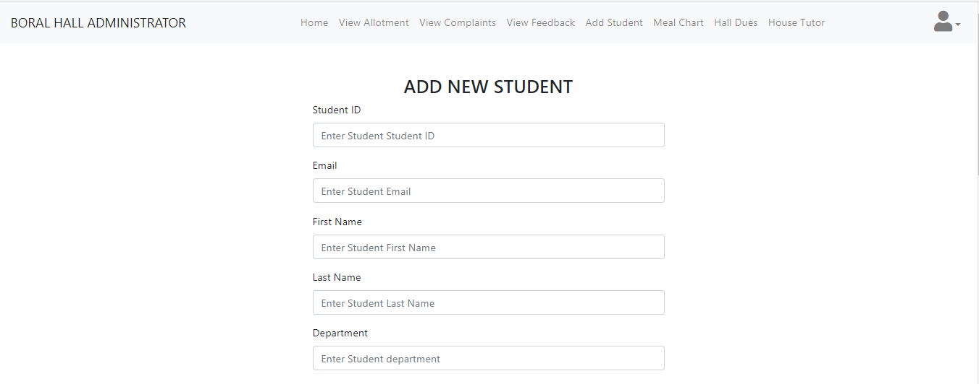

Fig 4.10: Add New Student

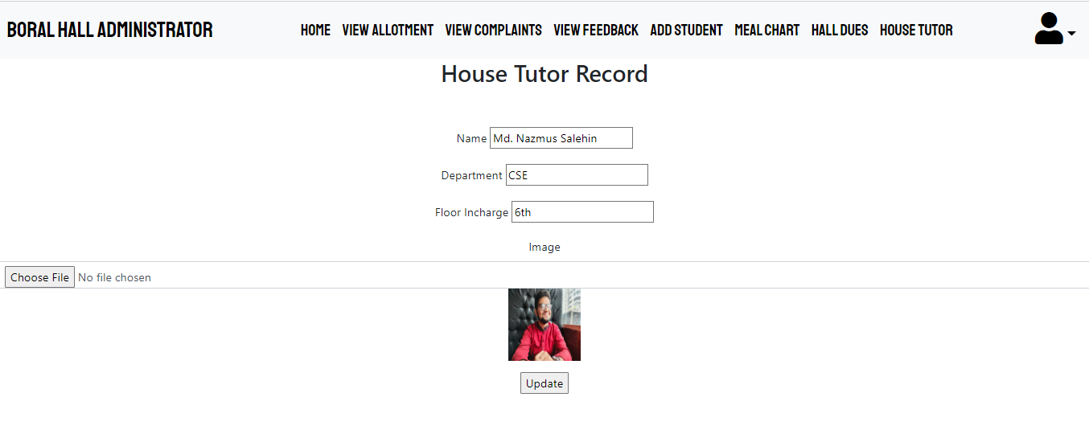

Fig 4.11: Update House Tutor

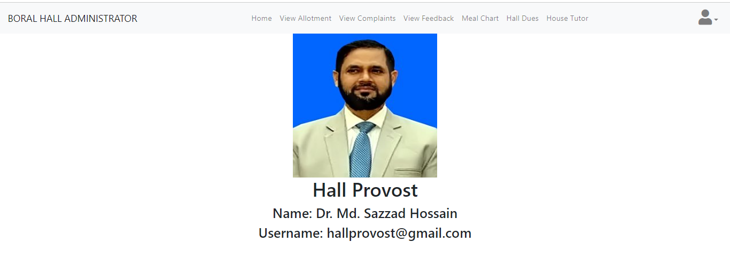

Fig 4.12: Hall Provost

**4.4 Conclusion**

The system proves to be advantageous for the student. The drag-and-drop interface application for automating multi-step processes across the platform can be done through workflow. It comprises of several sequential activities for instance record generated, users notified, pending approvals or scripts under process. The graphical Workflow Editor represents workflows visually as a type of flowchart. It shows activities as boxes labeled with information about that activity and transitions from one activity to the next as lines connecting the boxes.

**Chapter 5**

**SYSTEM TESTING AND INTEGRATION**

**5.1 Introduction**

System testing is testing conducted on a complete integrated system to evaluate the system's compliance with its specified requirements. System testing takes, as its input, all of the integrated components that have passed integration testing.

There are more than 50 types of System Testing. But it’s both time-consuming and unnecessary to do all the system testing. [15] [16] for our project Smart Hall Management System we have done the following testing:

1. Usability Testing– mainly focuses on the user’s ease to use the application, flexibility in handling controls, and ability of the system to meet its objectives
2. Load Testing– is necessary to know that a software solution will perform under real-life loads.
3. Regression Testing– involves testing done to make sure none of the changes made over the course of the development process have caused new bugs. It also makes sure no old bugs appear from the addition of new software modules over time.
4. Recovery testing – is done to demonstrate a software solution is reliable, trustworthy, and can successfully recoup from possible crashes.
5. Migration testing- is done to ensure that the software can be moved from older system infrastructures to current system infrastructures without any issues.
6. Functional Testing – Also known as functional completeness testing, Functional Testing involves trying to think of any possible missing functions. Testers might make a list of additional functionalities that a product could have to improve during functional testing.
7. Hardware/Software Testing – IBM refers to Hardware/Software testing as “HW/SW Testing”. This is when the tester focuses his/her attention on the interactions between the hardware and software during system testing.

After system testing comes the part of the system Integration. System Integration is the process of creating a complex information system that may include designing or building a customized architecture or application, integrating it with new or existing hardware, packaged and custom software, and communications.

**5.2 Features to be Tested/ Not to be Tested**

In software engineering, the most common definition of a test case is a set of conditions or variables under which a tester will determine if a requirement or use case upon an application is partially or fully satisfied. It may take many test cases to determine that a requirement is fully satisfied. In order to fully test that all the requirements of an application are met, there must be at least one test case for each requirement unless a requirement has sub-requirements. A Software feature can be strong as the changes made in the system to add new functionality or adapt the current functionality.

All features are supposed to have characteristics that are designed to be useful, intuitive, and effective. In realism, a new test set is shaped for testing that features consistent with the cycle of that announcement. The tremendously significant and usually used new features must be tested methodically in each build of that release and also reversion testing should be done pertinent to those areas.

This is a listing of what is 'not' to be tested from both the user's viewpoint of what the system does and a configuration management/version control view. This is not a technical description of the software, but a user's view of the functions.

* Identify why the feature is not to be tested, there can be any number of reasons.
* Not to be included in this release of the Software.
* Low risk, has been used before and was considered stable.

It will be released but not tested or documented as a functional part of the release of this version of the software.

Here is a list of features that will be tested and not tested:

|  |  |  |
| --- | --- | --- |
|  | Features | To be tested |
| Student | Students creates an account | YES |
| Update Account | YES |
| Generates Personal portfolio | YES |
| View Hall Dues | YES |
| View Meal Chart | NO |
| View House Tutor | NO |
| Give Complaints | YES |
| Give Feedback | NO |
| Admin | Approve Student | YES |
| Update Hall Dues | YES |
| Post News | NO |
| Update Student Profile | YES |
| View Complaints | NO |
| View Feedback | NO |
| Update Settings | YES |
| Upload House Tutor | YES |

Table 5.1: list of features that will be tested and not tested

**5.3 Testing Schedule**

Testing was carried out according to the scheme presented in the test plan. Initially, unit testing was carried out with the classes. Methods in the classes were tested by sending a specific input to a method and verifying that the method returns the expected value. Then another test was done on Sheik Rasel Lab and Games and Apps Development Lab on BAUET. The whole system was tested on 10 different Desktops in the lab. You can see the results in the test cases sections

After unit testing integration testing was carried out to discover the issues that arise when different modules are interacting with each other. Finally, system testing was done to check the overall functionality of the system. [12]

**5.4 Test Cases**

Test cases and expected results are displayed below:

|  |  |  |  |  |
| --- | --- | --- | --- | --- |
| Test Case No | Test Description | Testing Steps | Test Data | Expected Result |
| TC 01 | Validate input details in the login form | 1. Enter the user’s name according to  test data  2. Enter the password  according to  test data  3. Press login  button | Blank user name & blank password | Error message “Both Email and password are Empty” |
| TC 02 | Blank user name & given a password | Error message “Empty Email” |
| TC 03 | Given user name & blank Password | Error message “Empty password” |
| TC 04 | Wrong email and correct password | Error message “Invalid Email address or Password” |
| TC 05 | Correct email and wrong password | Error message “Invalid Email address or Password” |
| TC 06 | Both incorrect email & password | Error message “Invalid Email address or Password” |
| TC 07 | Correct email & correct password | Redirect to Dashboard |

Table 5.2: Login test case

|  |  |  |  |  |
| --- | --- | --- | --- | --- |
| Test Case No | Test Description | Testing Steps | Test Data | Expected Result |
| TC 01 | Validate inputdata in add a  member form | 1.Enter first name, last name, date of birth, gender, ID No, A/L batch, email, telephone no, role, image  according to test data  2. Press the save button | First name empty | Error message “Empty First  Name” |
| TC 02 | Last name empty | Error message “Empty Last Name” |
| TC 03 | Gender not selected | Error message “Please Select your gender” |
| TC 04 | Date and NIC not matching | Error message “Date and NIC not matching” |
| TC 05 | Empty A/L batch | Error message “Empty A/L batch” |
| TC 06 | Empty email | Error message “Empty email” |
| TC 07 | Email address used before | Error message “Already taken” |

Table 5.3: Member module test cases

|  |  |  |  |  |
| --- | --- | --- | --- | --- |
| Test Case No | Test Description | Testing Steps | Test Data | Expected Result |
| TC 01 | Validate input  data in add a product form | 1.Enter the product name, product type, category, size, and price according to the test data  2. Press the save button | Product name empty | Error message “Empty Product  Name” |
| TC 02 | Product type empty | Error message “Empty Product Type” |
| TC 03 | Category empty | Error message “Empty Category” |
| TC 04 | Price empty | Error message “Empty Price” |

Table 5.4: Product module test case

**5.5 Unit Testing**

UNIT TESTING is a type of software testing where individual units or components of software are tested. The purpose is to validate that each unit of the software code performs as expected. Unit Testing is done during the development (coding phase) of an application by the developers. Unit Tests isolate a section of code and verify its correctness. [9]

There is several automated unit test software available to assist with unit testing. We will provide a few examples below:

1. Junit: Junit is a free-to-use testing tool used for the Java programming language. It provides assertions to identify the test method. This tool tests data first and then inserted it into the piece of code.
2. NUnit: NUnit is a widely used unit-testing framework used for all .net languages. It is an open-source tool that allows writing scripts manually. It supports data-driven tests which can run in parallel.
3. JMockit: JMockit is an open-source Unit testing tool. It is a code coverage tool with line and path metrics. It allows mocking API with recording and verification syntax. This tool offers Line coverage, Path Coverage, and Data Coverage.
4. EMMA: EMMA is an open-source toolkit for analyzing and reporting code written in Java language. Emma supports coverage types like method, line, and basic block. It is Java-based so it is without external library dependencies and can access the source code.
5. PHPUnit: PHPUnit is a unit testing tool for PHP programmers. It takes small portions of code which are called units and tests each of them separately. The tool also allows developers to use pre-define assertion methods to assert that a system behaves in a certain manner. All of these unit tests were done with the help of our peers.

**5.6 Integration Testing**

INTEGRATION TESTING is defined as a type of testing where software modules are integrated logically and tested as a group. A typical software project consists of multiple software modules, coded by different programmers. The purpose of this level of testing is to expose defects in the interaction between these software modules when they are integrated.

The system was hosted in a test server and first tested by the developer herself. Then it was tested by a set of representatives from the association. They checked whether the system meets the operational needs of the association. Some modifications were requested by the representatives and after doing the necessary modifications system was deployed on the actual servers with real data.

The system was accessed with different privileges to check the functionality requested for each role was implemented properly. The system was accepted by the users and they expect that the association would function smoothly and efficiently after introducing the system.

**5.7 Conclusion**

A strong Student hall network is a source of recognition and pride for educational institutes. The hall network is an important factor considered by students while selecting universities, colleges, and schools. Smart hall management software solutions help educational institutes manage a large database of students, contact information, their e-mail addresses, and other details.

**Chapter 6**

**SYSTEM ISSUES**

**6.1 Introduction**

There are a few fundamental problems that software engineering faces. A fundamental problem of software engineering is the problem of scale; the development of a very large system requires a very different set of methods compared to developing a small system. In other words, the methods that are used for developing small systems generally do not scale up to large systems. A different set of methods has to be used for developing large software. Any large project involves the use of technology and project management. For software projects, by technology, we mean the methods, procedures, and tools that are used. In small projects, informal methods for development and management can be used. However, for large projects, both have to be much more formal. The cost of developing a system is the cost of the resources used for the system, which, in the case of software, are the manpower, hardware, software, and other support resources.

**6.2 Risk Analysis**

Risk management is simply a process of identifying, addressing, and managing risk. Risk assessment helps you prepare for uncertain and unexpected events that might negatively affect your project. Risk isn't only about safety. It involves technology, resources, people, and processes. There are five elements of project management risks.

Risk event: What can happen?

Risk timeframe: When is it most likely to happen?

Probability: What are the chances of this event?

Impact: What is the impact?

Factors: What can trigger the risk event?

Risk is the probability of the occurrence of a particular threat and the expected loss. E-risk involves the risk at the time of the electronic transaction, whereas threat means an anticipated danger. Common threats to computers are viruses, network penetrations, theft and unauthorized modification of data, eavesdropping, and non-availability of servers and personal computers. Risk is the probability of the occurrence of a particular threat and the expected loss. E-risk involves the risk at the time of the electronic transaction, whereas threat means an anticipated danger.

Common threats to computers are viruses, network penetrations, theft an dun authorized modification of data, eavesdropping, and non-availability of servers and personal computers. Risk is the probability of the occurrence of a particular threat and the expected loss. E-risk involves the risk at the time of the electronic transaction, whereas threat means an anticipated danger.  Common threats to computers are viruses, network penetrations, theft and unauthorized modification of data, eavesdropping, and non-availability of servers and personal computers.

**6.3 Cost Analysis**

The Cost Analysis refers to the measure of the cost–output relationship, i.e., the economists are concerned with determining the cost incurred in hiring the inputs and how well these can be re-arranged to increase the productivity (output) of the firm.

In other words, the cost analysis is concerned with determining the monetary value of inputs (labor, raw material), called the overall cost of production which helps in deciding the optimum level of production.

As the website was developed by us so there is no development cost for the website but developing the website is not enough it needs to be hosted and needs a domain. The current cost of the hosting is around 100$/month and the Domain price is 20$/year.

**6.4 Conclusion**

This is a very important project for our university. This system will be available for general public use through the web interface. Our hall management system solves the problem concerned with the student’s feedback to the hall with an inquiry module. In this module, the hall can define questions with answers to which active student can respond. This module should be used for collecting data that are not included in graduate’s profiles and have high information value for the faculty

**Chapter 7**

**MAINTENANCE**

**7.1 Introduction**

System maintenance is an ongoing activity, which covers a wide variety of activities, including removing program and design errors, updating documentation and test data, and updating user support.[11] For the purpose of convenience, maintenance may be categorized into three classes, namely:

i) Corrective Maintenance: This type of maintenance implies removing errors in a program, which might have crept into the system due to faulty design or wrong assumptions. Thus, in corrective maintenance, processing or performance failures are repaired.

ii) Adaptive Maintenance: In adaptive maintenance, program functions are changed to enable the information system to satisfy the information needs of the user. This type of maintenance may become necessary because of organizational changes which may include:

a) Change in the organizational procedures,

b) Change in organizational objectives, goals, policies, etc.

c) Change in forms,

d) Change in information needs of managers.

e) Change in system controls and security needs, etc.

iii) Perfective Maintenance: Perfective maintenance means adding new programs or modifying the existing programs to enhance the performance of the information system. This type of maintenance is undertaken to respond to users’ additional needs which may be due to the changes within or outside of the organization. Outside changes are primarily environmental changes, which may in the absence of system maintenance; render the information system ineffective and inefficient.

These environmental changes include:

a) Changes in governmental policies, laws, etc.

b) Economic and competitive conditions, and

c) New technology.

**7.2 Runtime Maintenance**

Run-to-failure (RTF) maintenance is a maintenance strategy in which assets are used until they break down or require repair or replacement. Though RTF maintenance is reactive, operational managers sometimes deliberately choose this maintenance plan. When used correctly, the strategy can help reduce costs, streamline maintenance work, and serve as a valuable addition to an organization’s maintenance toolkit.[16]

**7.3 System Security**

Security is the most important part of any website or development process which is related to the internet. We have done a lot of studies on different kinds of websites related to PHP, HTML, JavaScript, and CSS to make our website more and more secure. In the context of that, we found a lot of vulnerabilities and traced several methods for securing this.

For that, we made some protections and developments in it. Secured from: -

* SQL injection
* XSS
* File upload

SQL injection:

SQL Injection is one of the many web attack mechanisms used by hackers to steal data from organizations. It is perhaps one of the most common application layer attack techniques used today. It is the type of attack that takes advantage of improper coding of your web applications that allows hackers to inject SQL commands into say a login form to allow them to gain access to the data held within your database. In essence, SQL Injection arises because the fields available for user input allow SQL statements to pass-through and query the database directly.[17]

XSS (Cross-site scripting):

Hackers are constantly experimenting with a wide repertoire of hacking techniques to compromise websites and web applications and make off with a treasure trove of sensitive data including credit card numbers, social security numbers, and even medical records. Cross-Site Scripting (also known as XSS or CSS) is generally believed to be one of the most common application layer hacking techniques. The pie chart below, created by the Web Hacking Incident Database for 2011 (WHID) clearly shows that whilst many different attack methods exist, SQL injection and XSS are the most popular. To add to this, many other attack methods, such as Information Deschutes, Content Spoofing, and Stolen Credentials could all be side-effects of an XSS attack [13]

File upload:

This vulnerability is very dangerous. At the uploading point, hackers take advantage and upload shells to the website. If the shell is successfully uploaded by a hacker, then he/she can do anything with your website as well as the server. Shell provides interaction between software and hardware. Hackers can destroy your whole software. A server and steal your confidential information. Prevention: To make safety from this type of attack we use pre-defined secured code which is coded by OWASP. We use it on both sides of servers as well as the client-side. This Project is fully tested by the Security Analyst and fixes all the bugs. [10]

**7.4 Conclusion**

Student Portal for any university website is very important. It has been setup to increase interaction, knowledge sharing, and networking among the hall students and also focuses on bringing together hall students of the university the primary goal.

**Chapter 8**

**CONCLUSION & FUTURE SCOPE**

The application facilitates the learners to appeal for room booking and to acquire authorization from the superiors. An application should be designed to meet all of the client's defined specifications. There is no rule for the use of programming language. Instead there exists different technology that is being developed and one of them is Service now. Thus, the proposed software thereby attained for an optimal result This software therefore suggests an optimal solution for the need of the students to verify and see the status directly.

Several user friendly coding have also adopted. This package shall prove to be a powerful package in satisfying all the requirements of the organization. The objective of software planning is to provide a frame work that enables the manger to make reasonable estimates made within a limited time frame at the beginning of the software project and should be updated regularly as the project progress.

This website provides a computerized version of hall management system which will benefit the students as well as the visitor of the hall.

The following are the future scope for the project.

* Should be added payment gateway for students
* Can be added staff management system
* Can be added multiple halls
* Can be added multilingual to this site
* And many features can be added this project to make it more robust.

**REFERENCES**

[1] H. W. . M. R. Alan Dennis, Systems Analysis and Design, 2008. PP 10-23

[2] E. Erno-Kjolhede, “Project Management Theory and the Management of Research Projects”, MPP Working Paper No. 3/2000, ISBN:87-90403-70-3, Denmark, 2000.

[3] H. Kerzner, Project Management: A Systems Approach to Planning, Scheduling and Controlling, Eight Edition, John Wiley & Sons, 2003.

[4] I. Lovrek, M. Kos, B. Mikac, “Collaboration between Academia and Industry:

Telecommunications and Informatics at the University of Zagreb,” Computer

Communications, vol. 26, pp. 451-459, Elsevier, 2003

[5] Mieritz, L., Fitzgerald, D., Gomolski, B., Light, M.: Toolkit Best Practices: Program and Portfolio Management Maturity Model. (2007), PP- 2-4.

[6] Dooley, L., Lupton, G., O’Sullivan, D.: Multiple project management: A modern competitive necessity. J. Manuf. Technol. Manag. 16, 466–482 (2005).

[7] M. Á. R. O. Ana Isabel Molina, "A methodological approach for user interface development of collaborative applications: A case study," Science Direct, vol. 74, no. 9, pp. 754-776, 2009.

[8] T. Jewett, "Models and languages," [Online]. Available: http://www.tomjewett.com/dbdesign/dbdesign.php?page=models.html. [Accessed 19 April 2017]. PP 2-5.

[9] Rajegopal, S., McGuin, P., Waller, J.: Project Portfolio Management: Earning An Execution Premium. Palgrave Macmillan (2007)

[10] Cooper, R., Edgett, S., Kleinschmidt, E.: Portfolio management for new product development: Results of an industry practices study. R D Manag. 31, 361–380 (2001).

[11] Young, M., Conboy, K.: Contemporary project portfolio management: Reflections on the development of an Australian Competency Standard for Project Portfolio Management. Int. J. Proj. Manag. 31, 1089–1100 (2013).

[12] Beverly Pasian Dr Nigel Williams, D., Young, M., Young, R., Romero Zapata, J.: Project, programme and portfolio maturity: a case study of Australian Federal Government. Int. J. Manag. Proj. Bus. 7, 215–230 (2014).

[13] Peffers, K., Tuunanen, T., Gengler, C.E., Rossi, M., Hui, W., Virtanen, V., Bragge, J.: The design science research process: a model for producing and presenting information systems research. In: Proceedings of the first international conference on design science research in information systems and technology (DESRIST 2006). pp. 83–106 (2006).

[14] Mikkola, J.H.: Portfolio management of R&D projects: implications for innovation management. Technovation. 21, 423–435 (2001).

[15] Benbasat, I., Goldstein, D.K., Mead, M.: The case research strategy in studies of information systems. MIS Q. 369–386 (1987).

[16] Lima, A., Monteiro, P., Fernandes, G., Machado, R.J.: Dependency Analysis between PMI Portfolio Management Processes. In: ICCSA’2016, Lecture Notes in Computer Science, Springer, 2016. (accepted for publication), Beijing, China (2016).

[17] Young, M., Conboy, K.: Contemporary project portfolio management: Reflections on the development of an Australian Competency Standard for Project Portfolio Management. Int. J. Proj. Manag. 31, 1089–1100 (2013).